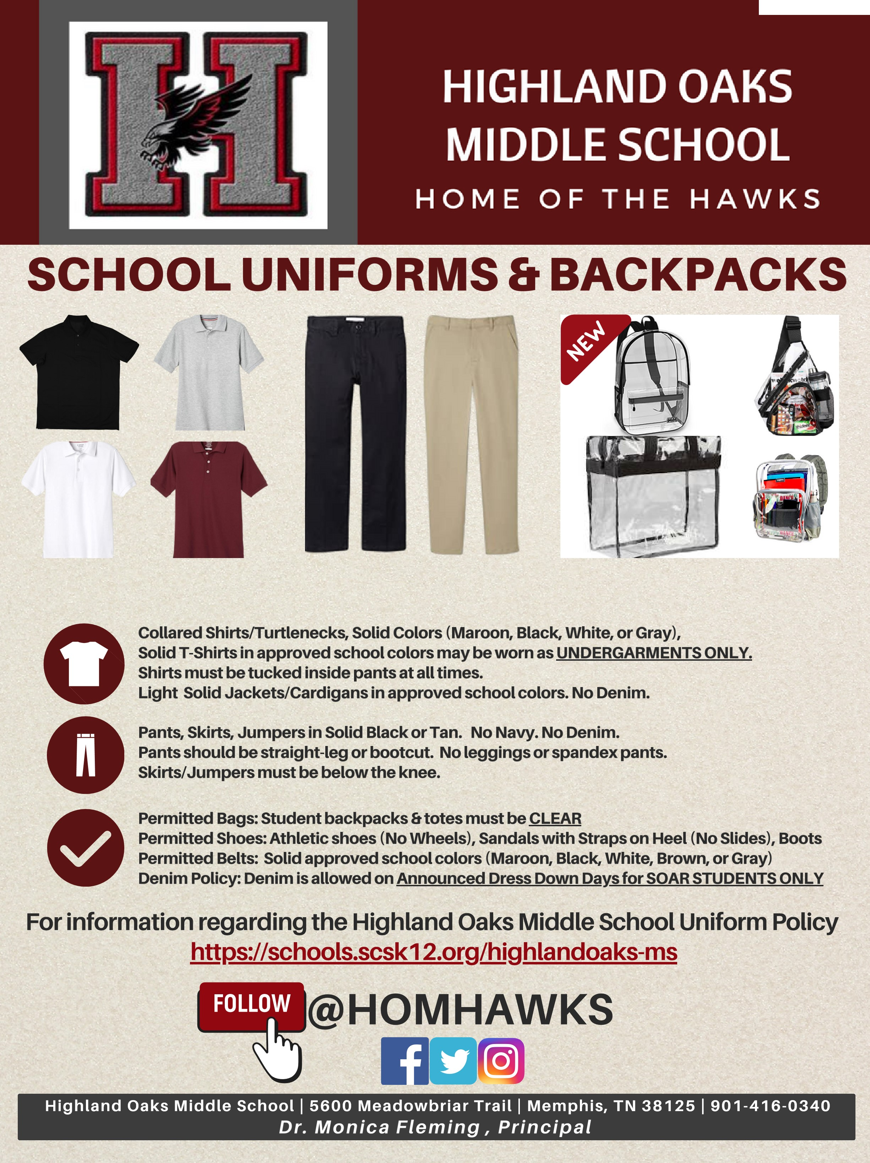

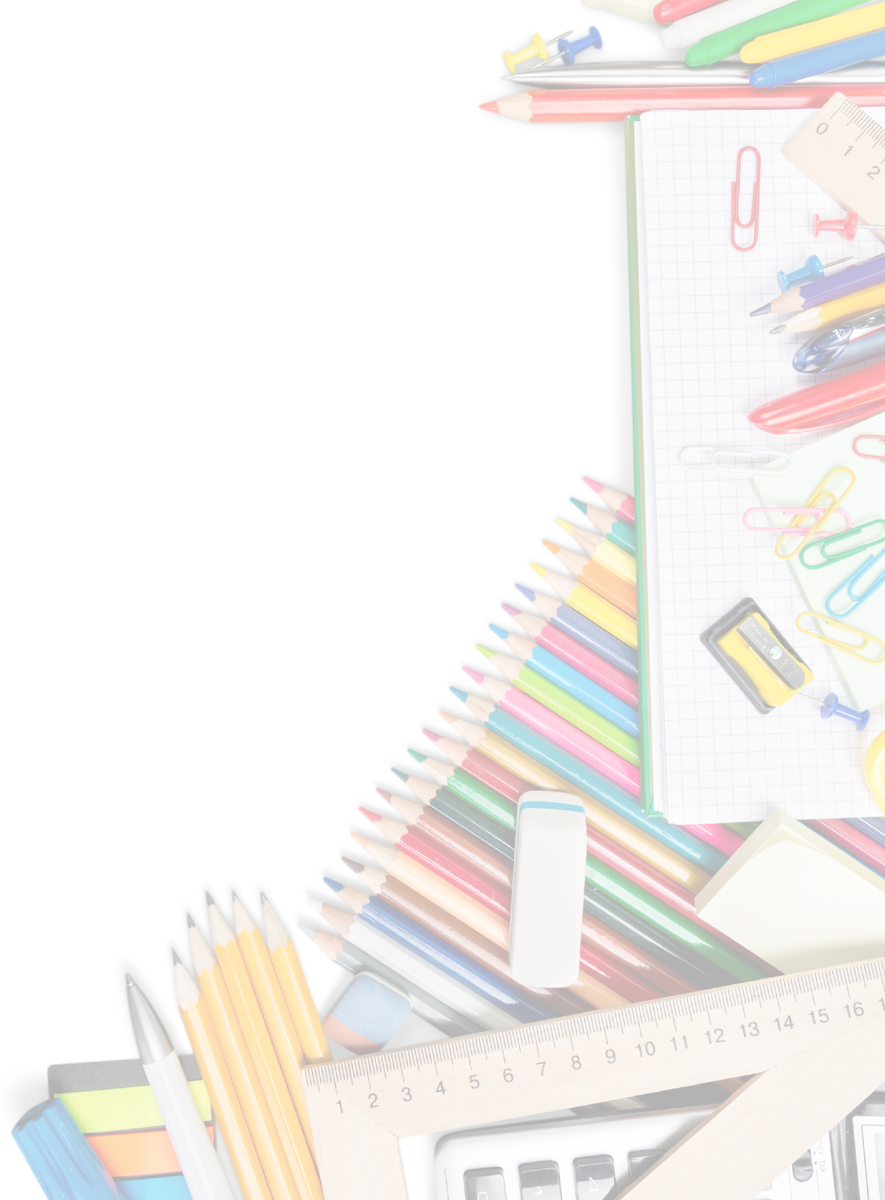

**@HOMHAWKS**



Large Clear Backpack; Pocket Folders with Prongs/Brads (Qty 4) ;

Clear

Zippered

Pencil Pouch (NO BOXES) ;

Colored pencils (Qty 12+);

Earbuds (Qty 2);

Highlighters

; Pink Erasers;

Index Cards (Qty 2 Packs); Dry erase markers;

#2 pencils (No Mechanical Pencils);

College-Ruled Composition Books (Qty 4, No

Spirals); 1-inch Binder (Qty 2); Sheet Protectors (Qty 25 pack)

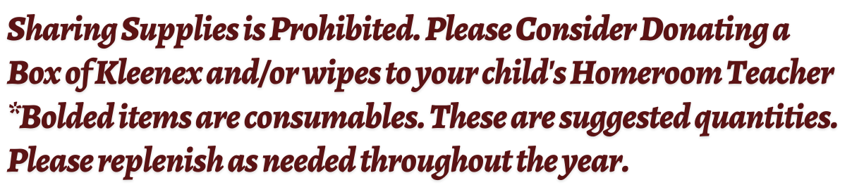

**Highland Oaks Middle School | 5600 Meadowbriar Trail | Memphis, TN 38125 | 901-416-0340**

Dr.

Monica

Fleming

,

Principal

SCHOOL

SUPPLY

LIST

Large Clear Backpack;

College Ru

le F

iller Paper (Qty 10 Packs);

#2 Pencils (Qty 24+);

1.5

” White View Binder (Qty 3);

Index Cards; Highlighters;

College Rule Spiral Notebooks (Qty 5); Composition Notebooks (Qty 2, No

Wire/Spiral); Elmer’s Glue Sticks; Pocket Folder with Brads (Qty 2);

Blue/Black Ink Pens

; Earbuds; Flash Drive (Qty 2)

Large Clear Backpack;

College Rule Filler Paper

;

Yellow Highlighters (Qty 2)

;

Blue/Black Ink Pens; Black Dry Erase Markers

; Pencil Pouch (NO BOXES);

Mechanical Pencils (preferred for safety reasons)

,

Mechanical Pencil Lead;

or

#2 Pencils;

Handheld Covered Pencil Sharpener; Erasers; Earbuds,

Colored Pencils

; Plastics Folders with Prongs/Brads (Qty 4: Red [Science], Green

Social Studies], Yellow [ELA], Blue [Math

[

])